Eyeconic-Storage Boxes Shop Management System

Use-Case Specification: Add Storage Boxes

Version <1.0>

Revision History

|  |  |  |  |
| --- | --- | --- | --- |
| **Date** | **Version** | **Description** | **Author** |
| <05/11/2019> | <1.0> | creating use case | Nguyễn Tuấn Anh |
|  |  |  |  |

Table of Contents

1. Add Storage Boxes 4

1.1 Brief Description 4

2. Flow of Events 4

2.1 Basic Flow 4

2.2 Exception 4

2.2.1 Add Storage Boxes 4

2.2.2 Fill in the Storage Boxes information 5

3. Special Requirements 5

4. Preconditions 5

4.1 Admin must be logged in 5

5. Postconditions 5

6. Extension Points 5

Add Storage Boxes

# Add Storage Boxes

## Brief Description

This use case defines the step of create/add a new Storage Boxes to the database.

Storage Boxes are added by the admin.

# Flow of Events

## Basic Flow

The system administration clicks a button to add a new item. The administrator fills the information of the new Storage Boxes. The system displays the new Storage Boxes and logs the change.

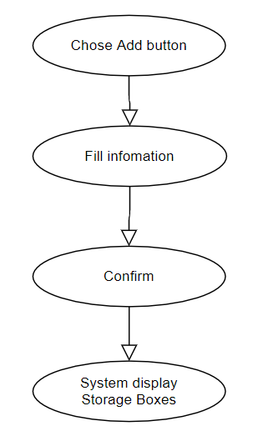

***Basic flow of Adding Storage Boxes***

Step 1: Click the add buttons

The modal view shows up

Step 2: Fill in the Storage Boxes information, name, type, …

Step 3: Confirming adding the Storage Boxes by clicking the “Save” button.

Step 4: Successful added Storage Boxes is displayed to the screen.

## Exception

### Add Storage Boxes

The add button cannot be clicked or isn’t appeared on the screen

### Fill in the Storage Boxes information

Invalid information.

Must fill out all the information in the form.

2.2.3 Confirming adding the Storage Boxes

The “Save” button is clicked but the new Storage Boxes are not added to the database.

This new Storage Boxes are existed in the database.

2.2.4 System displays added Storage Boxes

The added Storage Boxes is not display correctly

# Special Requirements

No Special Requirements

# Preconditions

* User must already login as the administrator of the website
* The added Storage Boxes had not existed in the database before.

# Postconditions

Storage Boxes are created, shown on the screen can be purchased by customers.

# Extension Points

Administrator check the website and the system to ensure that the Storage Boxes is added to the database and display on the screen.